**Title:** Lab 4: Zener Diode as a Voltage Regulator

**Name:** Robert Bara **Partner:** Dalton Hamilton, Mohamad Asaf, Abdulaziz Almersi

**General Objective:** The idea of this lab is to understand how Zener diodes perform in a circuit compared to regular diodes. This will be done by creating a Zener diode voltage regulator and running simulations within Multism.

**Background Activities:** Zener diodes differ than regular diodes because Zener diodes are designed to yield a lower breakdown voltage. By having a lower breakdown voltage, the Zener will have control over its breakdown, which makes the voltage across the diode, close to its breakdown voltage, keeping voltage stable and preventing any damage that may occur. Based on their voltage, a Zener diode will conduct either in forward or reverse bias. Zener diodes allow protection to the circuit similar to how resistors in series can limit current, multiple Zener diodes in series to ground will limit electrical voltage. Zener diodes can also be used to clip a signal, operate as a voltage shifter when wired to a resistor/potentiometer, and they can regulate voltage.

1. **Procedure**

**PART I:**

Start by launching Multism and create a Zener regulator by using a 12V DC source, Virtual Diode, a 1k input resistor, and 10k potentiometer to act as a load. Wire the circuit as shown below and place a voltage probe before terminal 1 of the potentiometer:

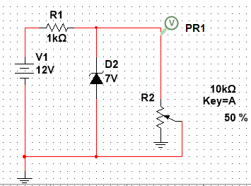

Figure . Zener Regulator Circuit

Select a DC sweep, set the start value to 0V, stop value to 20V, and increment by 0.1V, then run the simulation and record the graph generated as voltage vs voltage. Observe when the load voltage along the y-axis levels out. Change the value of the potentiometer and observe the changes within the graph, specifically within the regions that the diode conducts and does not conduct current.

**PART II:**

Observe a Zener diode’s IV characteristics using Multism’s IV analyzer and connect a 1N470A Zener diode in series to the respective positive and negative probes of the IV analyzer. Click on the IV analyzer and configure the settings under simulate parameters, setting the start voltage to -3V, stop voltage to 1.5V, and increment by 0.25V. Run the simulation in interactive mode and view the graph to analyze the breakdown voltage of a singular Zener diode.

**PARTII B**

Take the Zener diode circuit built in part I but modify the diode to be a 1N4740A Zener diode, and change the voltage source to be the NI Variable Power supply. Increase the voltage across the power supply and observe the voltage across the potentiometer while modifying the resistance. Set the power supply as +12V and modify the resistance. Assuming the resistance stays above 1K, notice that the resistance is almost constant despite modifying the voltage. The circuit should be wired as is below:

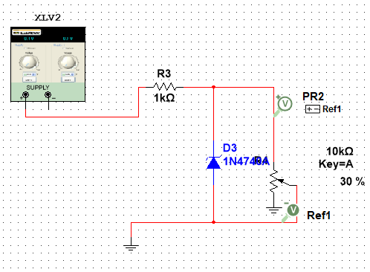

Figure . Zener Regulator Circuit with NI power supply

**Results:**

* 1. **Simulation Results:**

**PART I:** Below is the Zener regulator circuit using a generic power supply and ideal Zener diode.



Figure . My ideal Zener regulator circuit

With the potentiometer at 50% yielding approximately 5k, the DC transfer characteristic across the load is as follows with a breakdown voltage of about 9.82V when the power supply is about 12V:

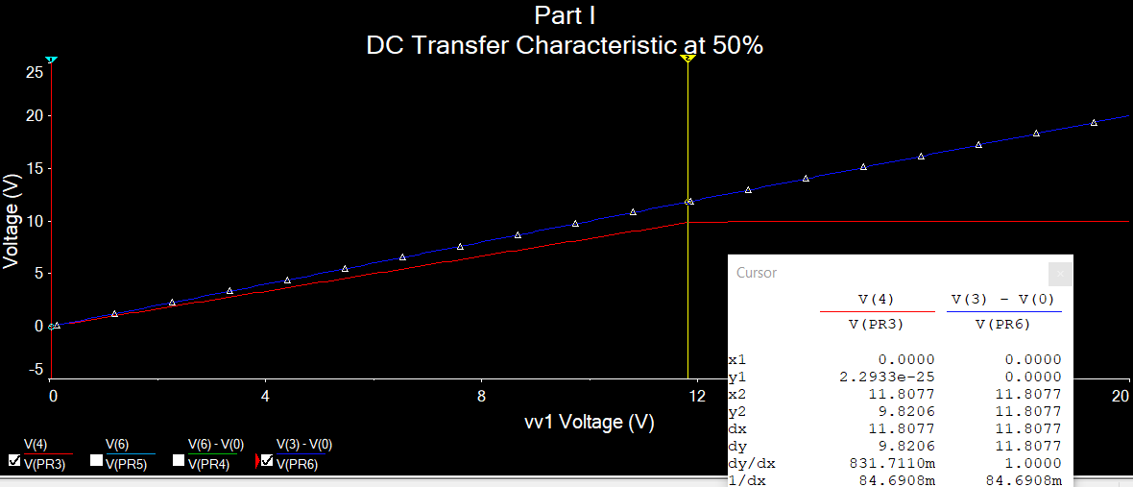

Changing the potentiometer to 100% or 10k, the breakdown voltage drops to about 9.78V when the power supply is at about 10V.

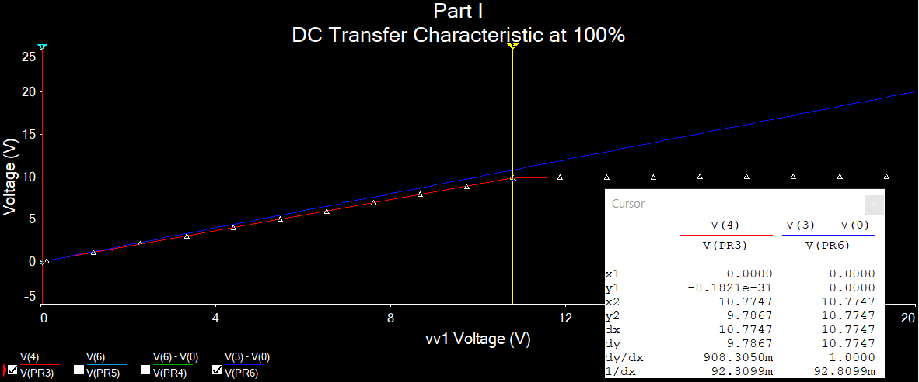

Changing the load to be 15% or 1.5k, the breakdown voltage is about 9.8V when the power supply is beyond the 12V source, at approximately 16V.

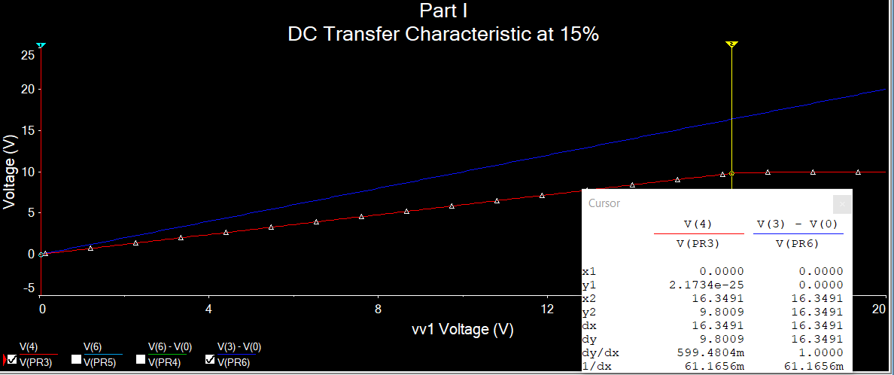

**PART II:**

Using the IV analyzer to measure the Zener diode:

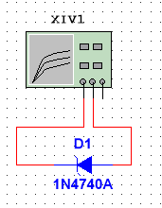

Figure . Circuit to measure the IV characteristic of the 1N4740A Zener Diode

Measuring the breakdown voltage of a Zener diode, the voltage is very small, at this reading of

-16.913mV, a negative current flows:

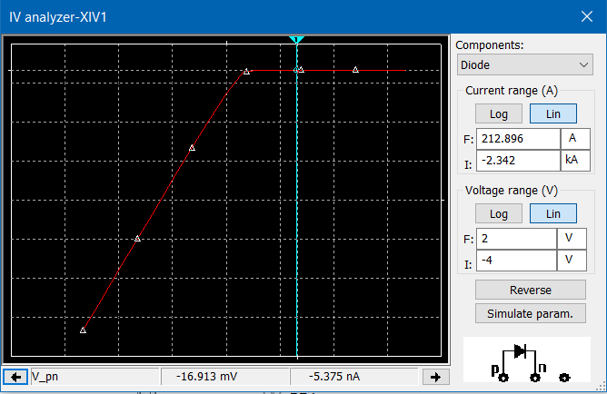

Figure . 1N4740A IV Curve

**PART II B:**

Building the Circuit using the NI Elvis Variable Power Supply.



Figure . Zener Regulator with NI Power Supply

Comparing the results from the simulation of part I, the input voltage as +12V, the breakdown voltage yields about 8V and stays consistent for the range of 4k to 9k when shifting the potentiometer, below is the reading at 5k, which matches close to the simulation within part 1:

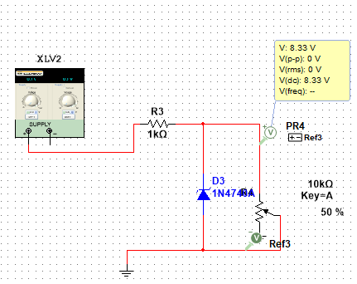

Figure . Vs=12V, RL=5k

Upon shifting the resistance to 10k, the voltage increases to about 9.09V.

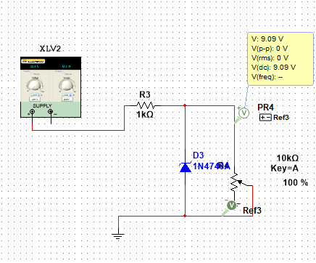

Figure . VS=12V, RL=10k

When setting the resistance to 1.5k, the voltage decreases to approximately 7.20V which is less than the breakdown voltage.

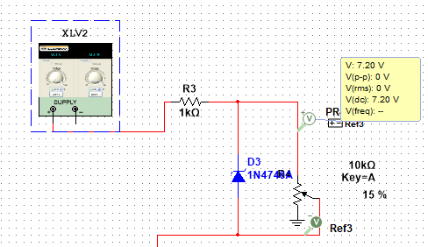

Figure . VS=12V, RL=1.5k

**Analysis:**

The Zener regulator stops working at lower load resistance values because there is too much current being drawn to the diode, which will drop voltage across the resistor and leave the Zener diode failing to conduct. This can be seen through results within part I and III.

When the voltage across the Zener diode is pushed beyond breakdown voltage, a “negative” or backwards flowing current is achieved and can be seen by the results taken within part II.

Given that we are measuring the voltage drop across a load resistor, when the voltage source is higher than the breakdown voltage, current flows through the diode and resistor and acts as a rectifier that creates a short circuit to ground.

1. **Conclusion:**

Based upon the simulations I ran within Multism, I was able to create a Zener regulator circuit and determine how a Zener diode will react upon a given input voltage. This was done by measuring a load resistance generated by using a 10k potentiometer in series with the Zener diode, so at a given voltage from the power supply, the diode will react a certain way based upon it’s breakdown voltage, depending on how current exits the diode, a voltage will be measured across the load potentiometer which allowed further analysis to determine when the Zener diode is being pushed beyond its breakdown voltage and what happens to the circuit.